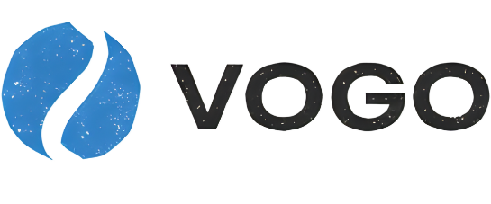
Vogo is a dynamic and growing organization committed to excellence. They pride themselves on fostering a supportive and inclusive workplace where every team member can thrive. As their Administrative Assistant, you’ll play a key role in ensuring smooth operations and supporting their team’s success. This position is a newly created position. Vogo, does not use artificial intelligence in the screening or selection process.
Administrative Assistant

Why you’ll love working with us:
At Vogo, we help Ontario businesses navigate complex financial landscapes. As our Administrative Assistant, you’ll be the backbone of our busy team—ensuring seamless operations so we can focus on delivering top-tier advisory services.
- Competitive Salary within the disclosed range
- Comprehensive health and dental benefits
- Hybrid work model (3 days in-office, 2 days working from home)
- Professional development stipend for courses/ certifications
- Supportive and inclusive workplace culture

As our Administrative Assistant, you will:
- Provide administrative support, including scheduling, correspondence, and document preparation.
- Manage office operations (supplies, meeting coordination, etc.).
- Assist with data entry, filing, and maintaining organized records.
- Serve as the first point of contact for visitors and phone inquiries.
- Support team projects and initiatives as needed.

What you will bring:
- High school diploma is required; post-secondary education in administration or related field is considered an asset
- Minimum one year in an administrative role is preferred
- Proficiency in Microsoft Office
- Strong organizational and communication skills
- Ability to multitask and work independently

Overview:
Location: [City, Ontario]
Status: Full-time; Hybrid position
Existing Vacancy: [Yes/No]
Expected Compensation: $60,000 – 75,000 NOTE: the range cannot exceed 50,000
How to Apply
Please submit your resume and cover letter to [email address] by [deadline].

